ASSIGNMENT
COMPUTER IN THE PAST, PRESENT AND FUTURE
A Detailed Study of the Evolution of Computing Technology

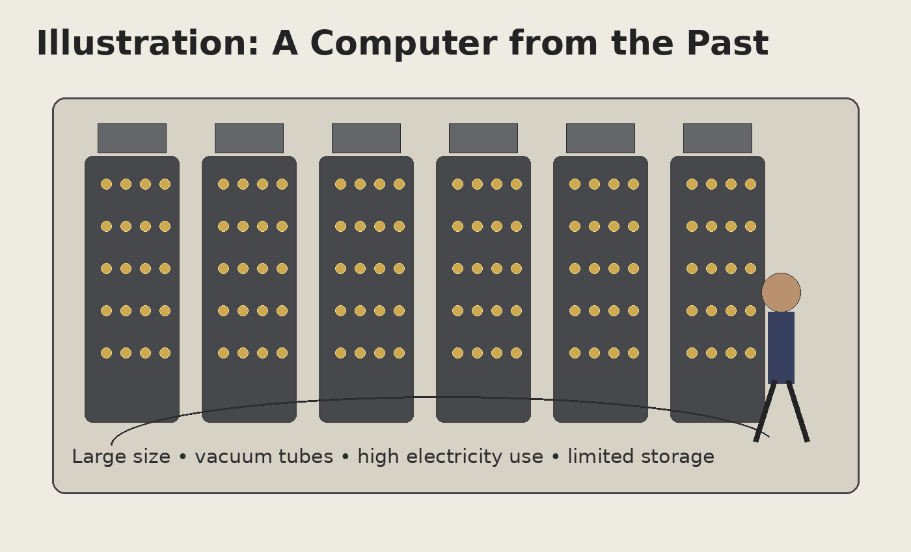
Figure 1: Illustration of the room-sized computers of the past.
Subject: Foundation Of Information Technology And Applications
Class: BIM 1st sem
Submitted by: Safal Dhakal
Roll No.: 25
Date: October 7

Table of Contents
- 1. Introduction
- 2. Objectives of the Assignment
- 3. Computer in the Past
- 3.1 Early Development and Characteristics
- 3.2 ENIAC
- 3.3 UNIVAC I
- 3.4 Limitations of Early Computers
- 4. Computer in the Present
- 4.1 Modern Computers and Devices
- 4.2 Uses in Different Fields
- 4.3 Artificial Intelligence and Cloud Computing
- 5. Computer in the Future
- 5.1 Expected Developments
- 5.2 Quantum Computing
- 5.3 AI, Robotics and Connected Life
- 6. Comparison: Past, Present and Future
- 7. Timeline of Computer Development
- 8. Advantages and Challenges of Computer Evolution
- 9. Conclusion
- 10. References

1. Introduction
A computer is an electronic machine that accepts data, processes it according to instructions, stores information, and produces useful results. The history of computing is a story of continuous improvement in speed, size, reliability, storage, connectivity, and usefulness. The computer that is carried in a school bag today is very different from the large machines that occupied entire rooms in the early period.
The source assignment describes the past computer as large, expensive and slow compared with modern computers, with important uses in scientific calculations, military purposes and research. It also notes that early machines had limited storage and processing power. In contrast, present-day computers are described as smaller, faster and more powerful, with applications in education, business, banking, hospitals, communication and entertainment. Looking ahead, the assignment expects artificial intelligence, robotics, cloud computing and quantum computing to influence the future of computing. fileciteturn0file0L2-L8 fileciteturn0file0L15-L21
Studying this development is important because it shows how human needs and technological innovation influence one another. As computers became more practical and affordable, their use spread from specialized laboratories into schools, homes, offices and almost every major sector of society.

2. Objectives of the Assignment
- To understand how computers changed from the past to the present.
- To describe the major characteristics of early computers.
- To examine the role of modern computers in everyday life.
- To explain important examples such as ENIAC and UNIVAC I.
- To explore possible developments in future computing.
- To compare the size, speed, storage, applications and intelligence of computers across different periods.
- To understand why artificial intelligence, robotics, cloud computing and quantum computing may become important.

3. Computer in the Past
The first generations of electronic computers were designed mainly for demanding calculations and specialized tasks. According to the original assignment, these machines were very large, expensive and slow compared with modern computers. Some occupied entire rooms and consumed a great deal of electricity. Their storage capacity and processing power were also limited by modern standards. fileciteturn0file0L2-L8
Figure 2: A school-friendly illustration of the physical scale and wiring of early computers.

3.1 Early Development and Characteristics
Early computers relied on technologies such as vacuum tubes and extensive electrical wiring. Because the components were physically large, the machines needed large rooms and substantial supporting equipment. Programming and operation could also require careful manual procedures. These limitations did not make the early computers useless; rather, they show how difficult and expensive computation was before miniaturization.
- Very large physical size and heavy equipment.
- High electricity consumption and heat production.
- High cost, meaning access was limited to governments, universities, research laboratories and large organizations.
- Limited memory and storage compared with current devices.
- Specialized use for calculations, research, military work and business applications.
- Lower reliability and more maintenance requirements than many modern systems.

3.2 ENIAC
ENIAC stands for Electronic Numerical Integrator and Computer. It is one of the most important early general-purpose electronic computers and is an example of the large-scale machines associated with the beginning of electronic computing. The original assignment identifies ENIAC as one of the earliest general-purpose electronic computers. fileciteturn0file0L9-L11
ENIAC demonstrates the enormous physical scale of early electronic computing. Its panels, wiring and components occupied a large space, while modern computing devices can perform far more work from a small portable device. Its historical importance lies not only in its size but also in showing that electronic machines could be used for general-purpose computation.
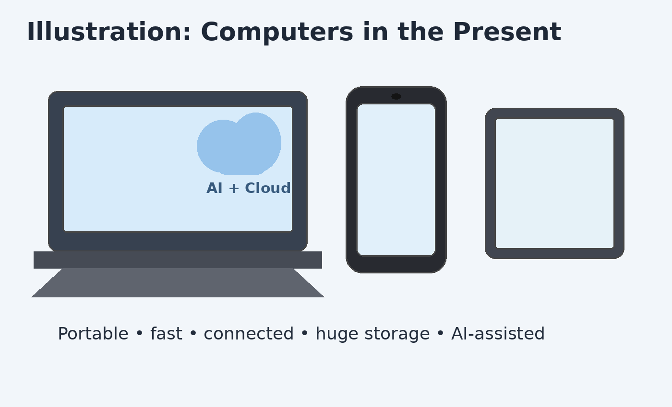
Figure 3: Modern portability provides a strong contrast with early room-sized systems.

3.3 UNIVAC I
UNIVAC I was an early commercial computer. The original assignment gives it as an example of a computer used for business and government. fileciteturn0file0L9-L13
The development of machines such as UNIVAC I helped demonstrate that computers could move beyond purely experimental or scientific settings and become useful for practical information processing. Business and government organizations could use computing technology to handle large amounts of information and support decision-making.

3.4 Limitations of Early Computers
Area | Past Computers | Effect
Size | Very large; often room-sized | Required special rooms and infrastructure
Cost | Very expensive | Limited access to wealthy organizations
Speed | Slow compared with modern systems | Complex tasks required substantial time
Storage | Limited | Less information could be stored
Power | High electricity consumption | Expensive operation and significant heat
Portability | Not portable | Computing stayed in fixed locations
Ease of use | Specialized operation | Required trained personnel
Connectivity | Limited | No everyday global internet access
Despite these limitations, early computers created the foundation for later technological progress. Their successes encouraged researchers and engineers to improve electronic components, memory, programming methods and manufacturing techniques.

3.5 Importance of Early Computers
The importance of early computers should not be judged only by their limitations. They proved that electronic calculation could be automated on a large scale. They also created knowledge and experience that contributed to later generations of computers. The progress from room-sized machines to portable devices was gradual, with improvements in components, software, storage, networking and manufacturing.

4. Computer in the Present
Modern computers are much smaller, faster and more powerful than the machines of the past. The source assignment states that present-day computing is used in education, business, banking, hospitals, communication and entertainment. It also identifies desktops, laptops and artificial-intelligence-powered computers as examples. fileciteturn0file0L15-L27
Figure 4: Illustration of common present-day computing devices and AI/cloud-assisted services.

4.1 Modern Computers and Devices
The present computer is not limited to a traditional desktop. Computing is now found in laptops, smartphones, tablets, smart devices, servers and specialized systems. Many of these devices can connect to the internet, communicate with other machines, access cloud services and use software designed for specific tasks.
- Desktop computers are common in offices, schools, laboratories and homes.
- Laptops combine portability with many of the functions of desktop computers.
- Tablets provide a portable touchscreen interface for learning, communication and media.
- Smartphones contain powerful processors and can perform many computer-like tasks.
- Servers provide services and resources to many users or devices over a network.
- AI-powered systems can assist with writing, data analysis, image generation and problem solving, as noted in the original assignment. fileciteturn0file0L22-L27

4.2 Uses in Different Fields
Field | Examples of Computer Use
Education | Online classes, digital notes, presentations, research, simulations, programming and learning platforms.
Business | Accounting, communication, inventory, marketing, customer management and data analysis.
Banking | Digital transactions, account management, record keeping and automated services.
Healthcare | Patient records, medical imaging, communication, research and administrative systems.
Communication | Email, messaging, video meetings, social platforms and information sharing.
Entertainment | Games, movies, music, photography, streaming and content creation.
Science and Research | Data processing, modelling, simulation, measurement and scientific analysis.
Government | Record management, public services, communication and administrative work.

4.3 Artificial Intelligence and Cloud Computing
Artificial intelligence is increasingly connected with modern computing. In simple terms, AI refers to computer systems designed to perform tasks that can involve pattern recognition, prediction, language processing, decision support or other forms of automated problem solving. The original assignment specifically notes AI-powered computers as systems that can help with writing, data analysis, image generation and problem solving. fileciteturn0file0L26-L27
Cloud computing allows computing resources such as storage, software and processing services to be accessed through networks rather than being completely dependent on a single local machine. Together, cloud services and AI can make computing more flexible and collaborative.

Benefits of Modern Computing
- Greater speed and processing capability.
- Large storage capacity and convenient access to information.
- Portability through laptops, tablets and smartphones.
- Fast communication over computer networks.
- Support for education, research, business and healthcare.
- Automation of repetitive tasks.
- Ability to work with large datasets.
- Access to online services and cloud-based applications.

Challenges of Modern Computing
- Privacy and protection of personal information.
- Cybersecurity threats and unauthorized access.
- Dependence on electricity, networks and digital infrastructure.
- Need for digital skills and continuous learning.
- Potential misuse of automated systems.
- Electronic waste when old devices are replaced.

5. Computer in the Future
The future of computing is difficult to predict precisely, but the original assignment expects computers to become faster, smarter and more advanced. It identifies artificial intelligence, robotics and cloud computing as areas that may play major roles. It also suggests that computers may become more connected with everyday life and help solve complex problems in science, education, medicine and technology. fileciteturn0file0L29-L38
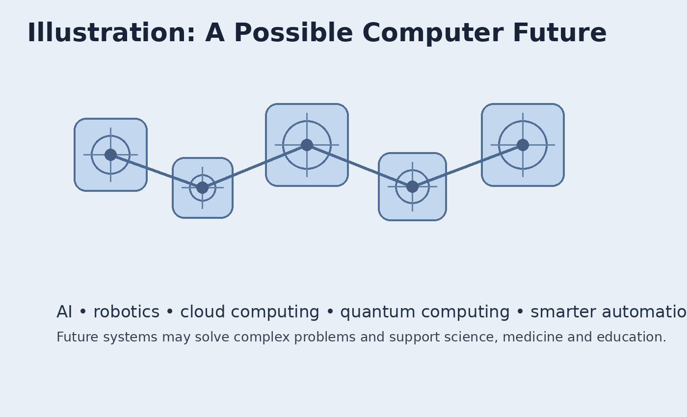
Figure 5: Conceptual illustration of possible future computing systems.

5.1 Expected Developments
- More intelligent software that can assist people with complex tasks.
- Greater integration between computers, sensors, robots and everyday devices.
- More advanced cloud-based computing and data services.
- Specialized hardware designed for AI and scientific computation.
- New approaches to solving problems that are difficult for conventional computers.

5.2 Quantum Computing
Quantum computing is a different approach to computation that uses principles from quantum physics. It is being researched for specialized problems where quantum methods may offer advantages over conventional computing. The original assignment gives quantum computers as an example of future systems that may solve certain complex problems much faster than conventional computers. fileciteturn0file0L36-L38
Quantum computing should not be understood as simply a faster version of an ordinary laptop. It is a specialized computing approach with different hardware, programming concepts and practical challenges. Its future value may depend on continued scientific and engineering progress.

5.3 AI, Robotics and Connected Life
Future computing may involve closer cooperation between software and physical machines. AI can help systems interpret information and make decisions, while robotics can allow computers to interact with the physical world. Cloud computing can connect devices and provide shared resources. The original assignment expects these areas to contribute to future computing. fileciteturn0file0L29-L35

6. Comparison: Past, Present and Future
Feature | Past | Present | Future (Expected)
Physical size | Very large | Small and portable | More compact/specialized
Processing | Limited by early hardware | Very high for everyday tasks | Potentially much more specialized
Storage | Limited | Very large | Likely to continue expanding
Connectivity | Limited | Internet and cloud connected | More deeply connected
Main users | Governments, research and large organizations | Almost everyone | Widespread and embedded
AI | Not a normal everyday feature | Widely used in many applications | Expected to become more capable
Robotics | Limited and specialized | Growing use | Potentially broader integration
Quantum computing | Not available as a practical modern technology | Research and development | Potential specialized applications
Portability | None for major systems | Very high | Potentially ubiquitous
Human-computer interaction | Specialized controls | Touch, voice, graphical interfaces | Potentially more natural and adaptive

7. Timeline of Computer Development
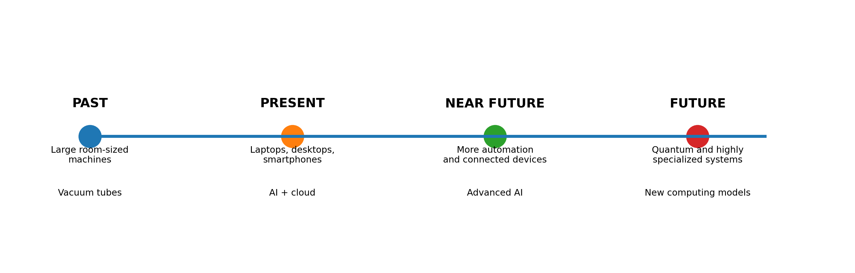
Figure 6: Simplified timeline showing the transition from early large systems to modern and future computing.
The timeline is a conceptual summary rather than a complete history. It highlights the broad direction of development: computers moved from large specialized systems toward smaller, connected and intelligent systems. The original assignment similarly organizes the topic into past, present and future and concludes that computers have developed from huge machines into powerful portable devices. fileciteturn0file0L43-L47

8. Advantages and Challenges of Computer Evolution

8.1 Major Advantages
- Computers save time by performing calculations and repetitive operations quickly.
- They make information easier to store, organize and retrieve.
- They support communication between people in different locations.
- They improve access to educational and research resources.
- They help organizations manage records and analyze data.
- They support creative work such as writing, design, programming, video and image production.
- They can automate tasks and assist humans in solving complex problems.

8.2 Major Challenges
- Rapid technological change can make skills and devices outdated quickly.
- People must protect passwords, accounts and personal information.
- Organizations need responsible policies for data and automated systems.
- Overdependence on digital systems can create difficulties when services fail.
- Electronic waste must be managed responsibly.
- Students and users need digital literacy so they can evaluate information and use technology safely.

8.3 Impact on Students and Education
For students, the change from past to present computing is especially visible. A student can now use a small laptop or smartphone to read digital material, prepare presentations, communicate with teachers, write programs and access learning resources. In the future, AI-assisted learning and more advanced educational technologies may provide additional support. However, technology should support learning rather than replace careful thinking, practice and independent understanding.

9. Conclusion
Computers have developed through a remarkable transformation. The original assignment describes the past as a period of huge, expensive and relatively slow machines used mainly for scientific calculations, military purposes and research. It then describes the present as an era of smaller, faster and more powerful computers used across education, business, banking, healthcare, communication and entertainment. Finally, it looks toward a future shaped by artificial intelligence, robotics, cloud computing and quantum computing. fileciteturn0file0L2-L8 fileciteturn0file0L15-L21 fileciteturn0file0L29-L41
The most important lesson from this development is that computer technology is not static. Improvements in hardware, software, networking and scientific knowledge continue to change what computers can do. The future may bring systems that are more intelligent, more connected and more specialized. At the same time, responsible use, privacy, security, digital literacy and environmental responsibility will remain important.
In conclusion, the computer has moved from a large specialized machine to a powerful everyday tool. The original assignment summarizes this progression by stating that computers have developed from huge machines in the past to powerful portable devices today and are expected to play an even greater role in daily life in the future. fileciteturn0file0L43-L47

10. References
- Primary source: Uploaded assignment, “Assignment 1.docx” — topic and original organization: Computer in Past, Present and Future. fileciteturn0file0L2-L13
- Primary source: Uploaded assignment, present-day computer section. fileciteturn0file0L15-L27
- Primary source: Uploaded assignment, future computer section and conclusion. fileciteturn0file0L29-L47
- Wikimedia Commons was consulted for historical computer imagery during preparation; the document itself uses original educational illustrations so the images can be embedded directly and cleanly.
— END OF ASSIGNMENT —

